**MY CV**

**Hello there….**

**My name is *osimi* *Godsgift*..**

**Am glad to have you going through my CV …**

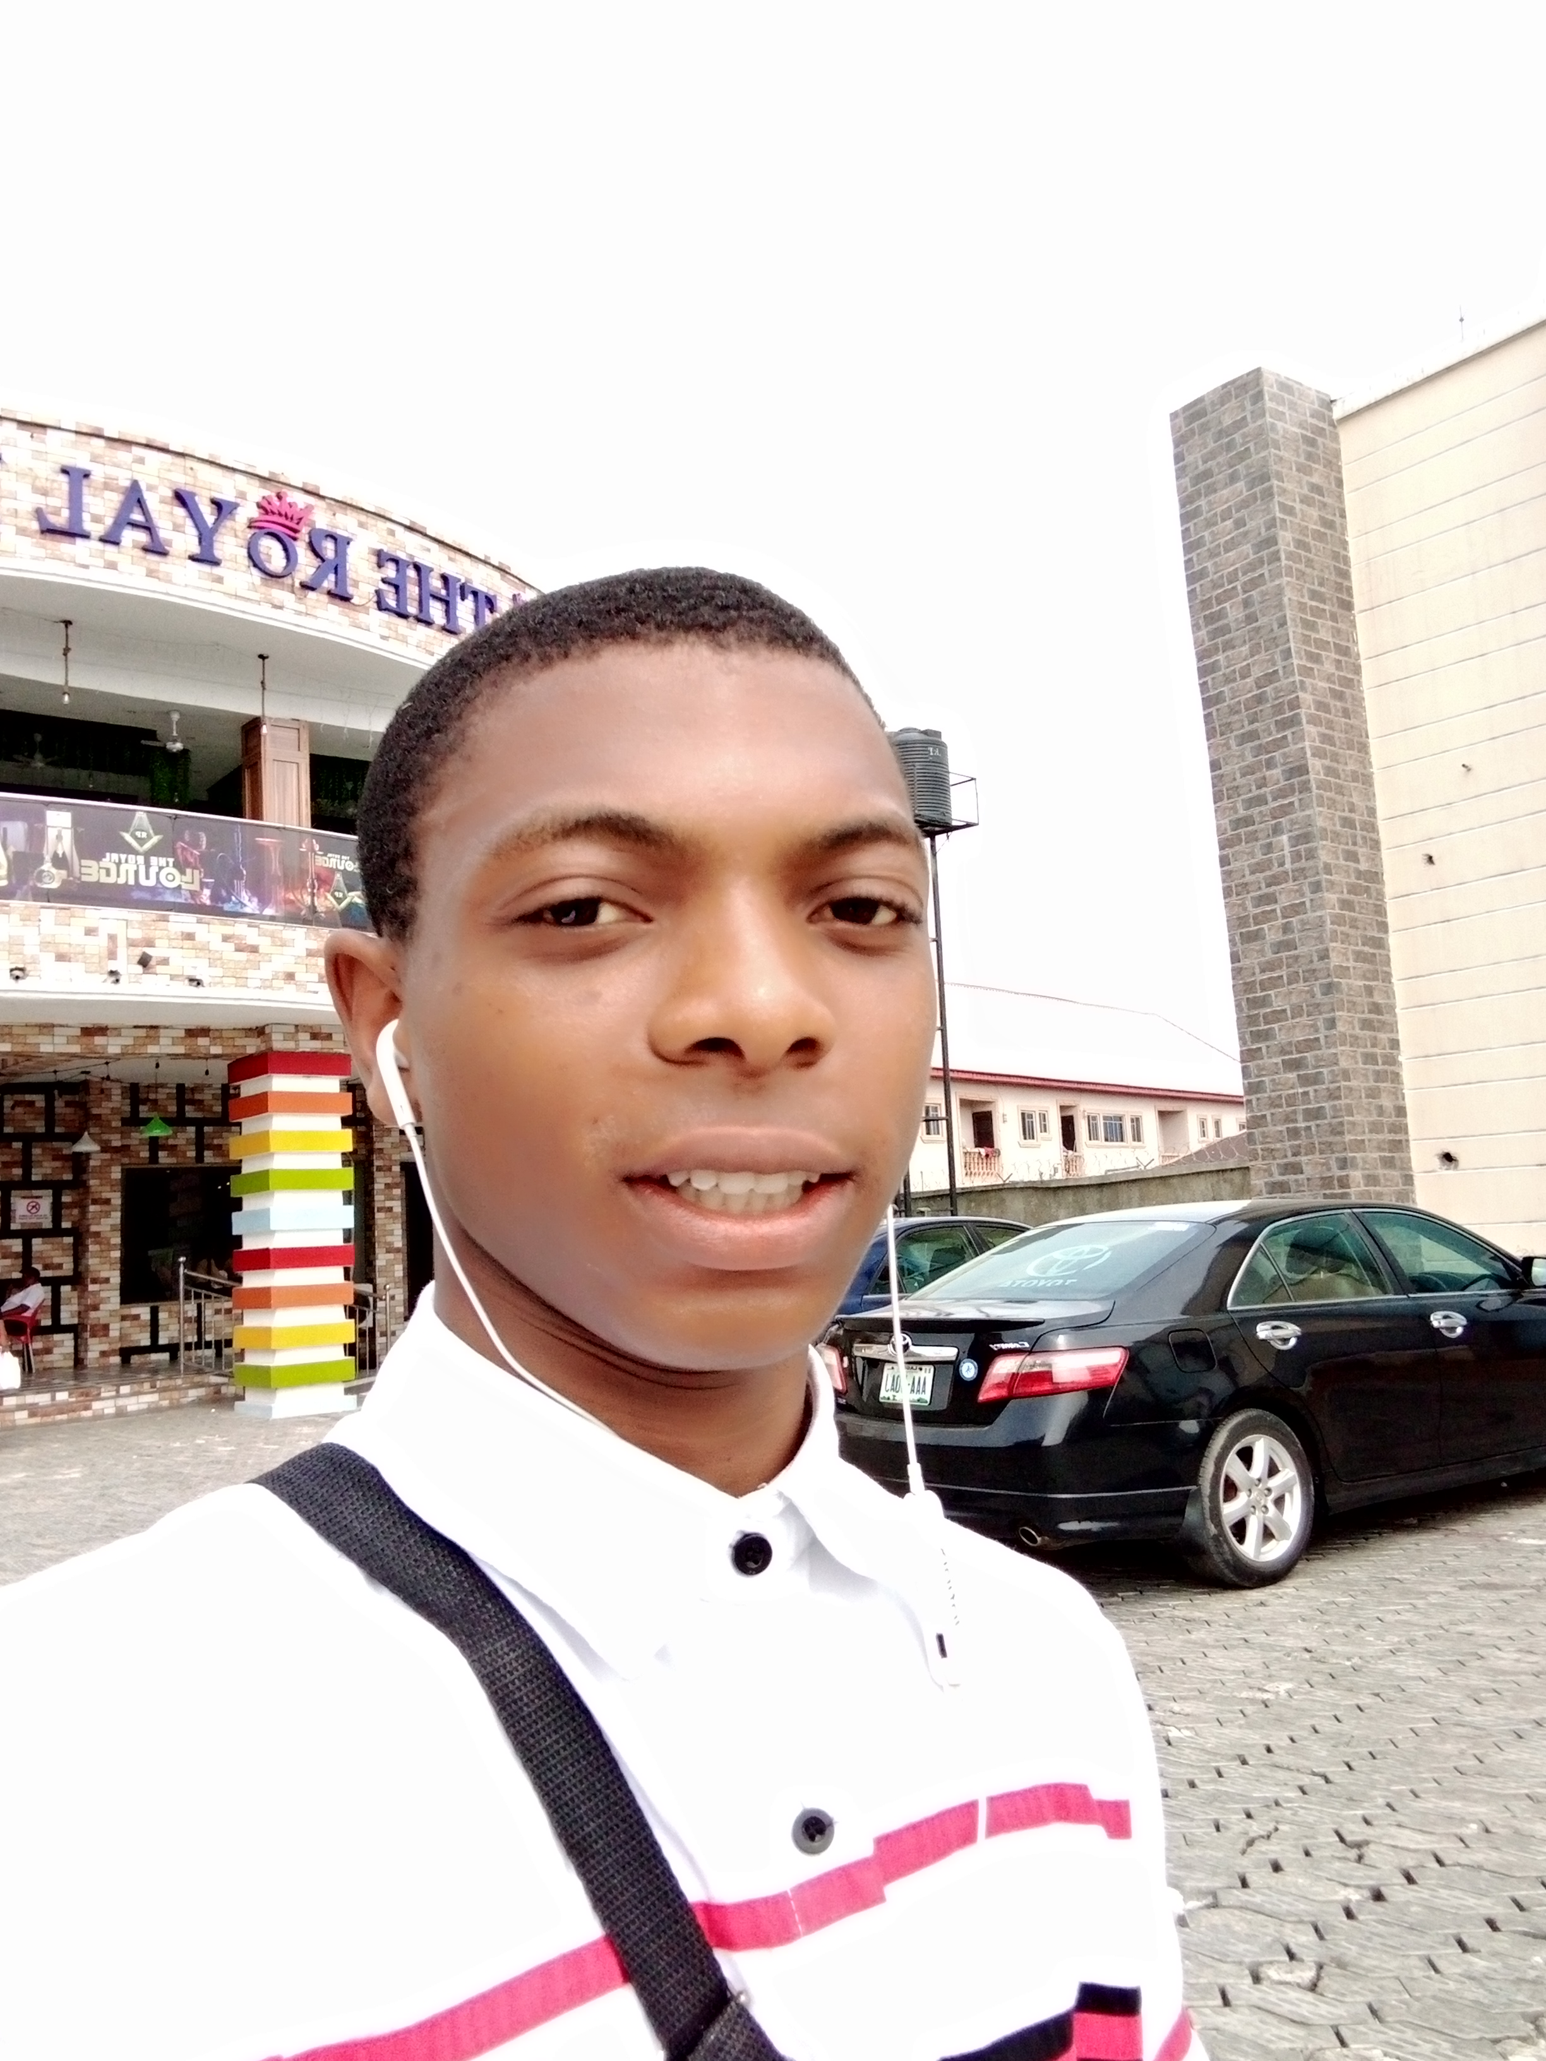

# AddresS

# Shell road by Mona school, sapele Delta state Nigeria.

# 08169641654

# Social media handles

[Facebook account](https://www.facebook.com/profile.php?id=100008468178563)

[LinkedIn](https://www.linkedin.com/in/osimi-godsgift-85907723a/) 



[Twitter](https://twitter.com/GbubemiOsimi?t=wivBfuHSB_2IWiBEOUfsmg&s=09)



[Github](https://github.com/Osimi-Gift)

# Email address

[osimigodsgift@gmail.com](mailto:osimigodsgift@gmail.com)

# Experience

* I am an undergraduate of the federal university of technology Owerri Imo state Nigeria
* My journey into the tech field kicks strat with my training at the I4G zuri training
* I have Had other online course like the Tony Elumelu foundation business management training that is currently ongoing, I am currently a participant of that program.
* Outside that I attended a technical college which help in building in that engineering sense in me.
* I have represented my college back in my school days in exhibition at some events
* And in one of these event I had the privileged of meeting the vice president and the governor of my state, who were happy at my performance (vice president)

# Education

* I was the head boy of my college then in secondary school
* I hold the position as the president of a fellowship
* I was also the class captain.
* I am currently the Team Director/Founder of the CBS Team a body of software developers by God's grace
* I have been awarded a trade test certificate in mechanical engineering craft practice (mecp) , which was issue to me after my three years of study in my college.
* I also have the basic SSCE certificate

# SKILLS

* **FRONTEND DEVELOPER**
* **POULTRY COUNSULTANT**
* **TILER**

# PREFERED LANGUAGE

* **HTML**
* **CSS**
* **JavaScript**

**What I can do for you**

* **Create the UI for your website.**
* **Frontend development**
* **Consultant for your poultry business**
* **I can help integrate payement gateway into your existing website**
* **Help you organize data in tables.**
* **Creation of forms, login forms, registration forms and survey .**
* **Mentorship and training.**

# PROJECTS DONE SO FAR

* **Creation of my very own website, you can follow the link below to access that** [**Website built on Replit**](https://replit.com/@Osimi-Gift/ZURI-TRAINING-WEBSITE-TASKS-FRONT-END?v=1)
* **Creation of a shopping website** [**MY SHOPPING WEBSITE**](https://osimi-gift.github.io/SHOPPINGHUB/index.html)
* **Website creation and payment Integration** [**Website/Payment Integration**](https://the-cbs-team.github.io/complete_prototype/)
* **Lunched The CBS TEAM and created our website** [**CBS TEAM WEBSITE**](https://osimi-gift.github.io/THE-CBS-TEAM/)
* **Arrangement of student data in a organized way using HTML and CSS.**

# Learning platform

I started my tech journey at the **I4Gzuritraining** in the year **2022**, the training started **May**, I registered as a **frontend** **developer** and am done with that training now.

**I also had other training from** [**Alison**](http://alison.com) **a learning space, where I took Javascript and jQuery courses**

**I also participated in the Side hustle internship as a frontend developer**

# Awards and Acknowledgements &Certification

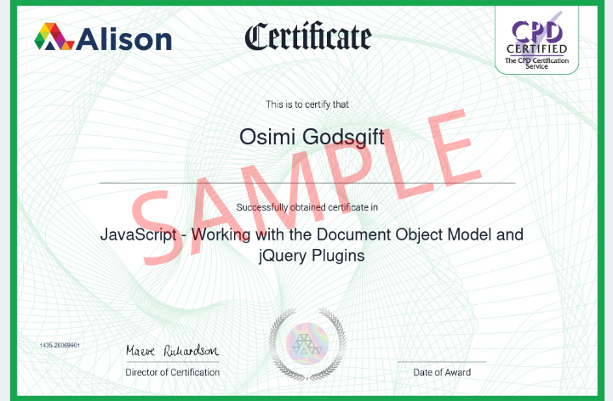

**Javascript DOM Course Certification**

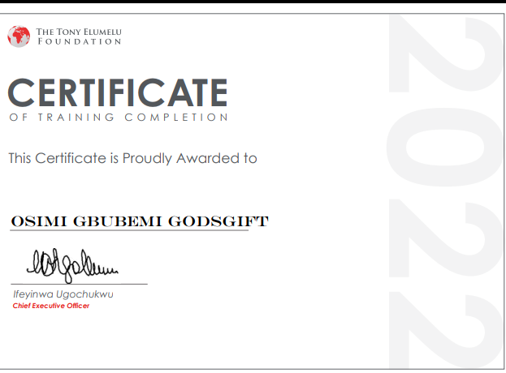

**TEF BUSINESS MANAGEMENT**

**TRAINING CERTIFICATION OF PARTICIPATION**



**The CBS Team was lunched July 2022 by me…**

**Here is an** [**Article**](https://osimi-gift.github.io/My-Article/) **written to that effect, you can take your time to go through it..**

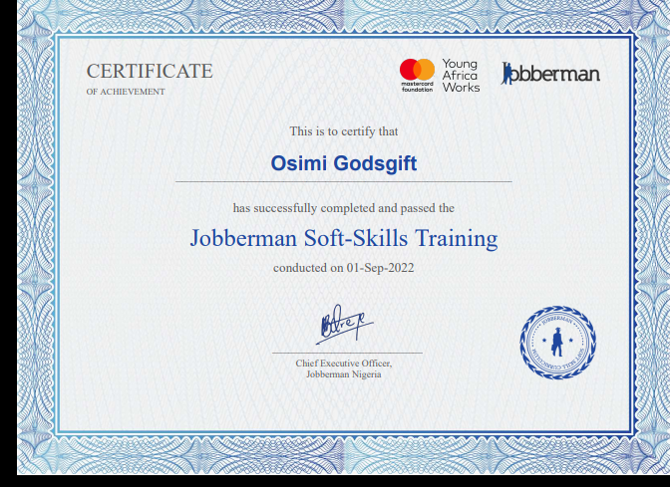

**Jobbers man soft skill certicate**

**PERSONAL ATRRIBUTE AND QUALITIES**

* The ability to organize and lead people has always been with me by God’s grace
* That inquisitive attribute I have by God’s grace make me do and venture a lot of things.
* Never giving up on several trials is my nickname if I were to have one
* If we put this quality together with the help of other of my teammate we would achieve great things in the coming future.

**Contact**

**You can add me on Whatsapp, so that we can talk further**

[**Whatsapp link**](https://wa.me/qr/CIZKTQIERD42P1)

**Copyright 2022**